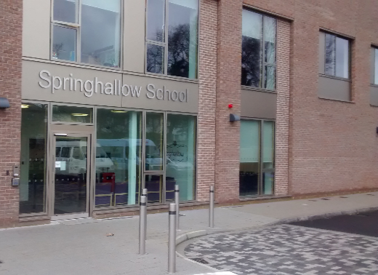
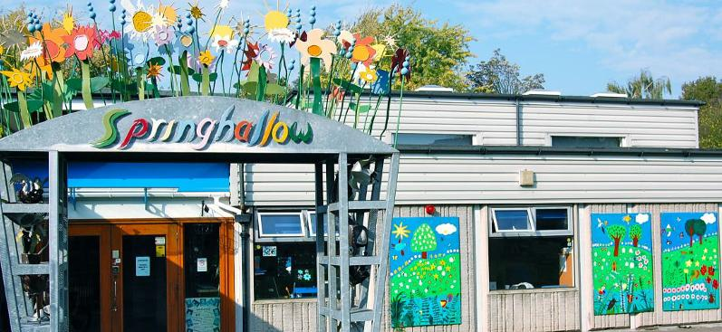
Alumni Event

Are you an ex-student of Springhallow or Post 16?
We are inviting past Students* to come and join us on
Thursday 30th March, 5pm – 7pm
*Year 11 and 14 students will be invited to hear all your stories!
For an evening of games, refreshments and lots of fun!
Event taking place at Post 16, 485 Greenford Road, Greenford, UB6 8SR
Please email or call to confirm your attendance: post16@springhallow.ealing.sch.uk
Tel: 020 8998 2700 (option 1)

